- Python
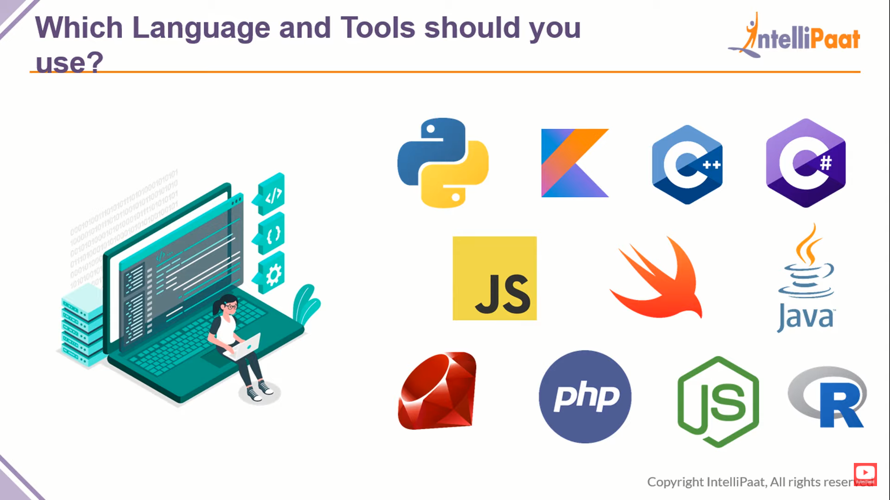
- Kotlin

- C++

- C#

- JavaScript
- Swift

- Java

- Ruby

- PHP

- Node.js
- R

